Kindergarten Olympics Timeline

Date: Friday, November 18

Time: 9:00-10:00

|  |  |  |  |
| --- | --- | --- | --- |
| **Time** | **Event** | **PIC** | **Comment** |
| 9:00 – 9:05 | Opening Ceremony |  |  |
| 9:05 – 9:10 | Procedure Announcement |  |  |
| 9:10 – 9:15 | Rotation 1 |  |  |
| 9:15 – 9:20 | Transition and familiarization |  |  |
| 9:20 – 9:25 | Rotation 2 |  |  |
| 9:25 – 9:30 | Transition and familiarization |  |  |
| 9:30 – 9:35 | Rotation 3 |  |  |
| 9:35 – 9:40 | Transition and familiarization |  |  |
| 9:40 – 9:45 | Rotation 4 |  |  |
| 9:45 – 9:50 | Drink and Gather |  |  |
| 9:50 – 9:55 | Closing Ceremony |  |  |
| 9:55 – 10:00 | Dismiss |  |  |

Staff Allocations

|  |  |  |
| --- | --- | --- |
| **Name** | **Role** | **Comment** |
|  | KA Group 1 |  |
|  | KB Group 2 |  |
|  | KA Group 1 |  |
|  | KB Group 2 |  |
|  | KA Group 3 |  |
|  | KB Group 3 |  |
|  | KA Group 4 |  |
|  | KB Group 4 |  |
|  | Scorer Station 1 |  |
|  | Scorer Station 2 |  |
|  | Scorer Station 3 |  |
|  | Scorer Station 4 |  |

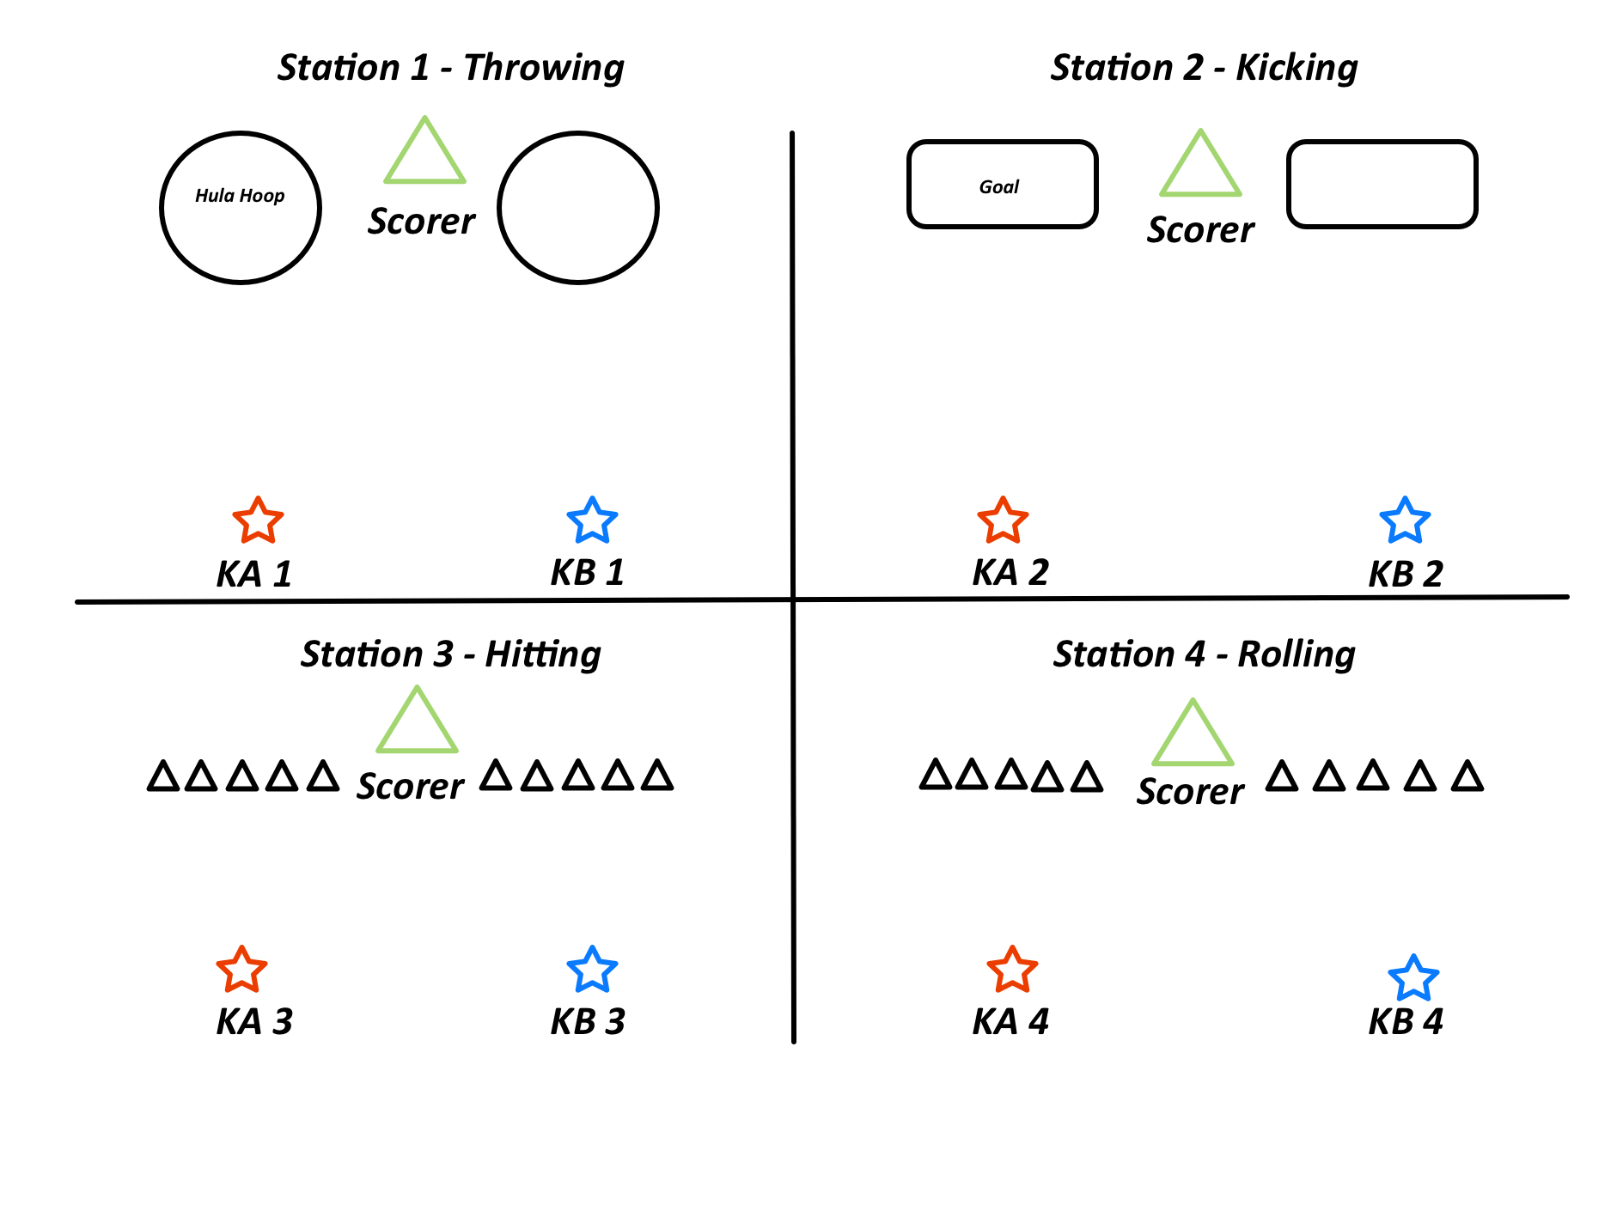

Station 1 – Throwing:

* Students form two lines – KA and KB,
* One at a time within each team, students throw the beanbag into the hula-hoop.
* Beanbag lands in the big hula-hoop = 1 point, medium hula-hoop = 2 points, small ring = 3 points.

Station 2 – Kicking:

* Students form two lines – KA and KB,
* One at a time within each team, students kick the ball from the set location.
* Kicker runs picks up the ball and gives to the next person in line.
* 1 goal = 1 point.

Station 3 – Hitting:

* Students form two lines – KA and KB,
* One at a time within each team, students have a paddle and hit the ball towards the targets.
* 1 target down = 1 point.
* Once all pins are down, quickly place them back up and continue until time expires.

Station 4 – Rolling:

* Same as above but with rolling.
* Ensure ball is rolling and not underhand thrown.
* If thrown – no points.